🏛️ IA
- Voir aussi 🤖 IA

Tour
- Tour d'horizon : Framamia !
- Vocabulaire et petit dictionnaire
- Rapport du Sénat : ChatGPT, et après ? Bilan et perspectives de l'intelligence artificielle

AI Literacy
- AI Literacy: Thinking with the Machines
- AI suggestions make writing more generic, Western

TeachAI
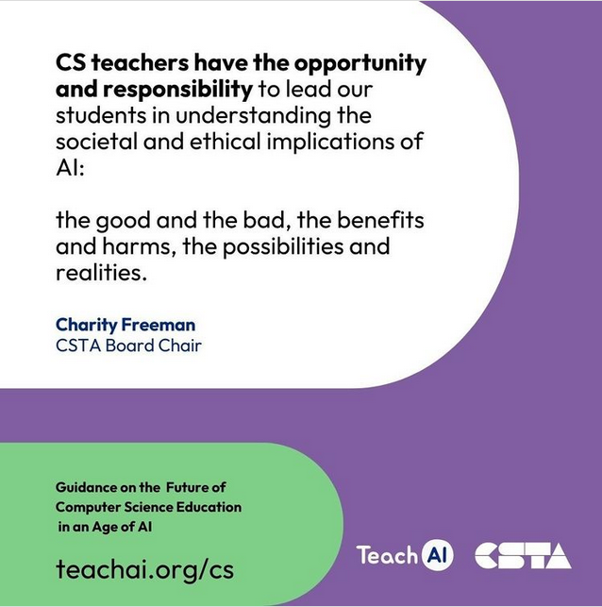
- teachai.org : guidance
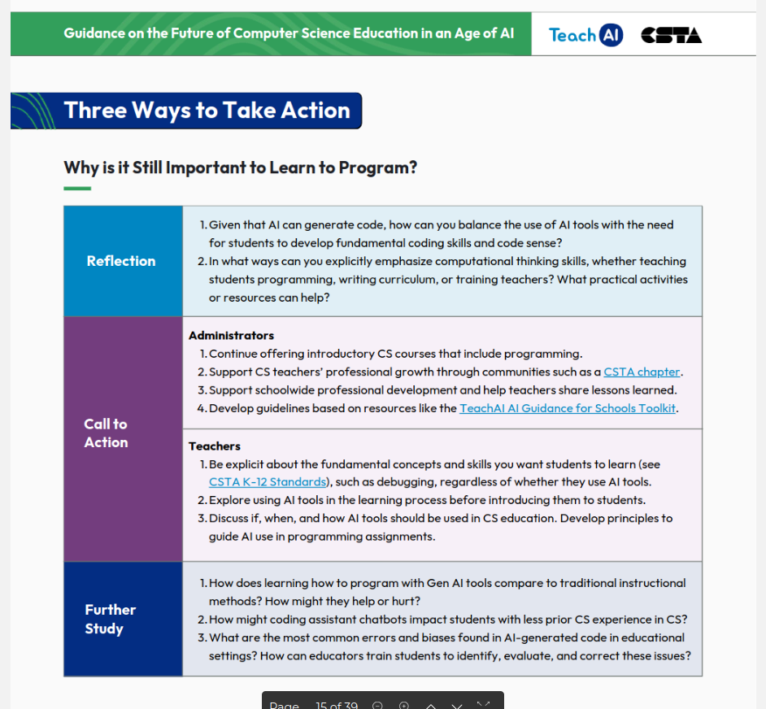

Les limites de l'IA
- A Right to Warn about Advanced Artificial Intelligence
- Powering Intelligence: Analyzing Artificial Intelligence and Data Center Energy Consumption
- Rethinking open source generative AI: open-washing and the EU AI Act (pdf)
- I got fooled by AI-for-science hype—here's what it taught me

Les risques de l'IA
- International AI Safety Report
- AI Tools in Society: Impacts on Cognitive Offloading and the Future of Critical Thinking
- Your Brain on ChatGPT: Accumulation of Cognitive Debt when Using an AI Assistant for Essay Writing Task :« As the educational impact of LLM use only begins to settle with the general population, in this study we demonstrate the pressing matter of a likely decrease in learning skills based on the results of our study. » ... Il est peut-être préférable ... d'apprendre à coder !
- The Impact of Generative AI on Critical Thinking: Self-Reported Reductions in Cognitive Effort and Confidence Effects From a Survey of Knowledge Worke (pdf)

